NexmoSMS app

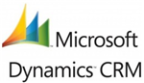

“An app to send SMS when an opportunity is added or a lead is converted into an opportunity”

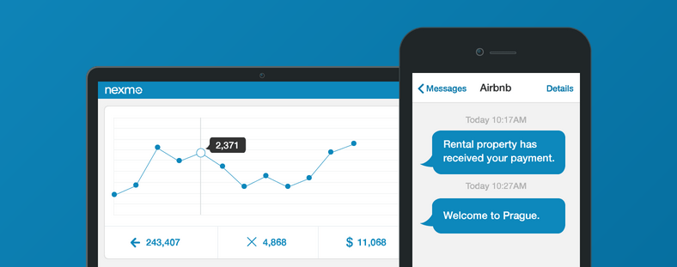

Contents

Introduction 3

Use Case 3

Prerequisite 3

Features 3

Steps to install NexmoSMS app 3

Steps to use the NexmoSMS app 10

Appendix 12

Nexmo API Keys 12

# Introduction

NexmoSMS app for Microsoft Dynamic CRM integrates Nexmo SMS APIs with the platform and allows users to enable SMS functionality in the platform. The app will send a predefined SMS whenever a new opportunity is created, updated or a lead qualifies into an opportunity on the CRM platform. User can define the threshold for the budget amount and an SMS will be sent in case the opportunity’s budget amount is more than the threshold value.

# Use Case

1. Sales Executive adds a new opportunity or qualifies a lead into an opportunity, and adds the expected budget amount to that opportunity, the app will send an SMS to the respective Sales Manager if the opportunity budget value is above the threshold amount.

SMS that will be sent to the Sales Manager: “**A new opportunity <<Title>> for <<Account>> with probable value <Budget value> has been added**.”

1. Sales Executive updates the budget amount of any opportunity, the app will send an SMS to the respective Sales Manager if the opportunity budget value is above a threshold amount.

SMS that will be sent to the Sales Manager: “**An opportunity <<Title>> for <<Account name>> has been updated with probable value < Budget value>**.”

# Prerequisite

* Nexmo subscription and corresponding Nexmo API key and Secret key to consume Nexmo services. To access Nexmo’s API keys, see the appendix section.
* On Microsoft Dynamic CRM, phone number should be in international format.
* Each salesperson should have an assigned manager.
* Each assigned manager should have a mobile number updated in the CRM System.

# Features

* Send SMS to the respective manager when the opportunity’s budget amount is more than the threshold value.
* The app allows to enable and disable SMS functionality.
* SMS will be delivered when user updates any existing CRM Opportunity.
* No SMS will be delivered if the respective manager doesn’t have a mobile number updated in the CRM System.
* Opportunity creation process will not get impacted in case SMS sending fails.

# Steps to install NexmoSMS app

1. Login to Dynamic CRM Online
2. Dynamic CRM dashboard will appear as below:

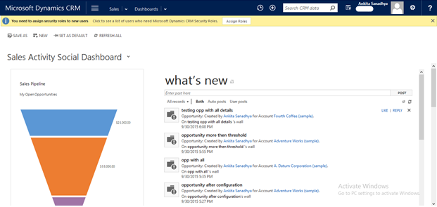

1. On the dashboard, click on menu  icon. Select ***Settings > Solutions*** for package installation as shown in the image below:

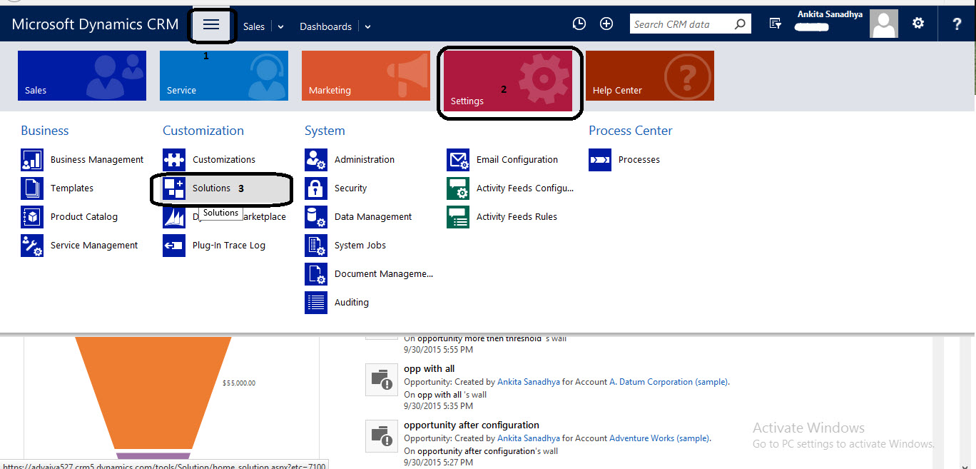

1. On **All Solutions** screen, click on **Import** button to import solution package.

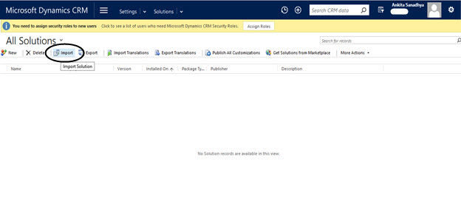

1. On**Import Solution** wizard, click on the **Browse** button to choose the file to be uploaded.

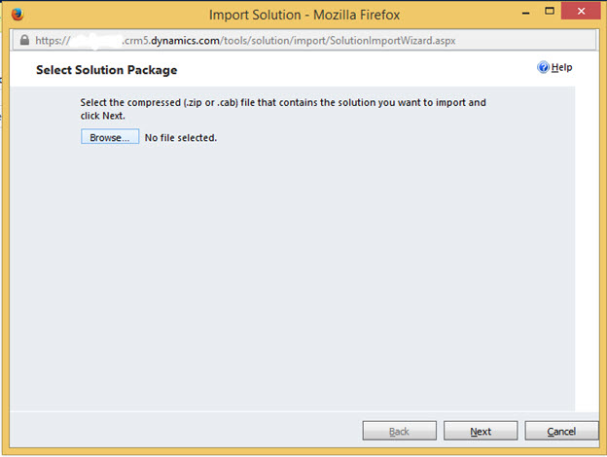

1. Select ZIP file **NexmoSMSPackage_1_0_0_0_managed.zip** stored on local system and click on **Open** button.

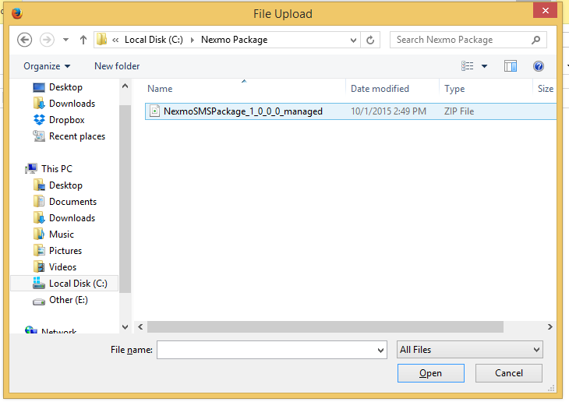

1. On the next screen, click on the **Next** button of this screen.

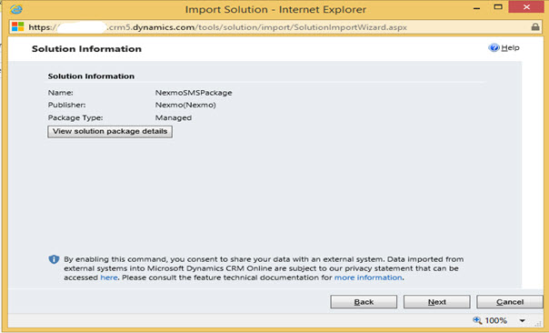

1. Again click on the **Next** button.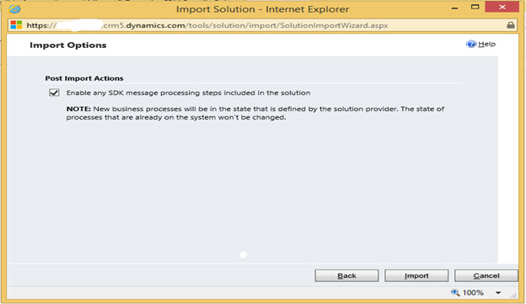
2. Click on **Import** button, and the file uploading process starts.

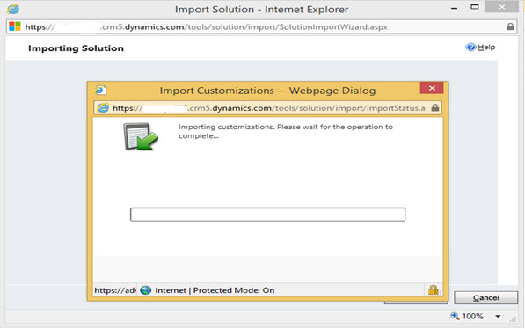

1. Click on **Close** button.

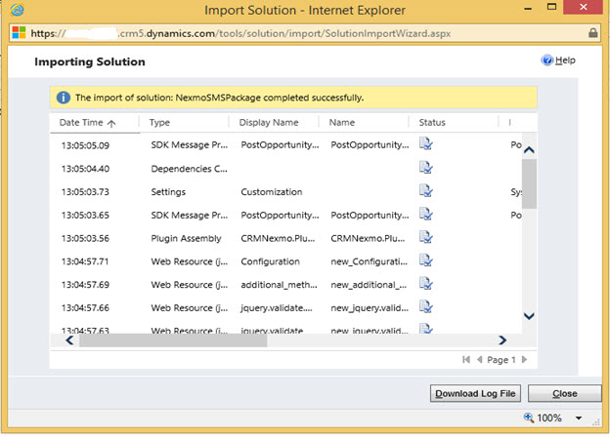

1. Next screen will show the installed package.

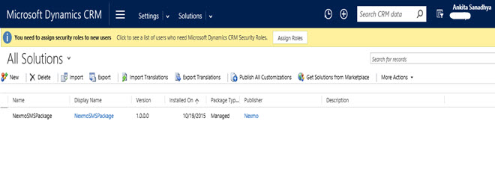

1. Click on the **Package name**, it will open configuration form for Nexmo setting.

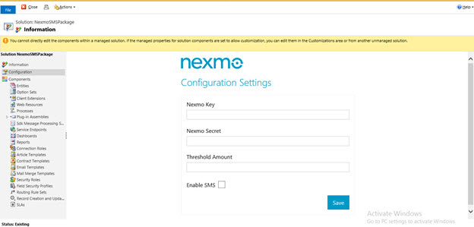

1. Provide the following details:
   1. Nexmo Key
   2. Nexmo Secret
   3. Threshold Amount
2. Enable Nexmo SMS checkbox to allow the app to send SMS and click on **Save.**
3. Click on the **Close** button.
4. On **All Solutions** screen, select **NexmoSMSPackage** solution and click on **Publish All Customization** button.

# Steps to use the NexmoSMS app

1. Click on the  icon, select **Sales**tab and click on **Opportunities** to create an opportunity.

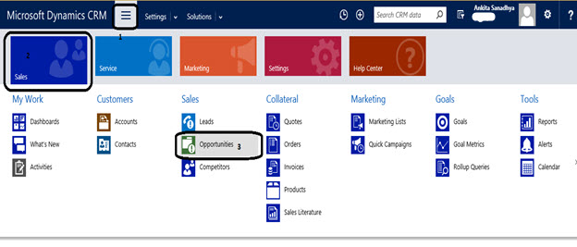

1. Click on the **NEW** button to add a new opportunity.

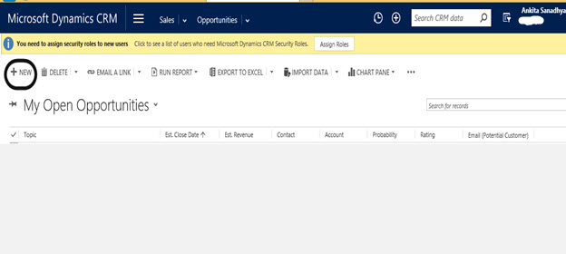

1. Fill the opportunity details with at least these mandatory fields (Topic, Account and Budget) and click on **SAVE and CLOSE** button.

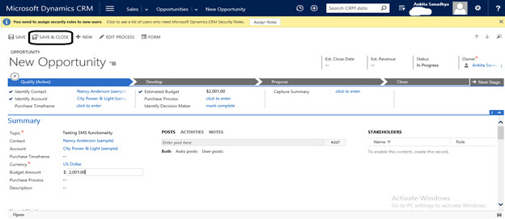

1. New Opportunity is created and SMS is also delivered to the manager.

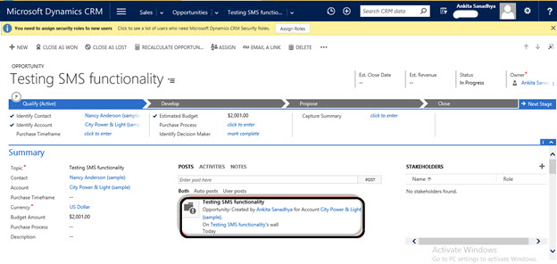

1. Manager will receive an SMS as per the following format:

“**A new opportunity <<*Title*>> for <<*Account*>> with probable value <<*Budget value*> has been added**.”

# Appendix

## Nexmo API Keys

* To access Nexmo keys, go to <https://www.nexmo.com/> and sign-in
* On the top right corner, click on the **Api Settings**
* Key and Secret will display in the top bar as shown in the below image:

